SNEHSADAN FOUNDATION, NASHIK
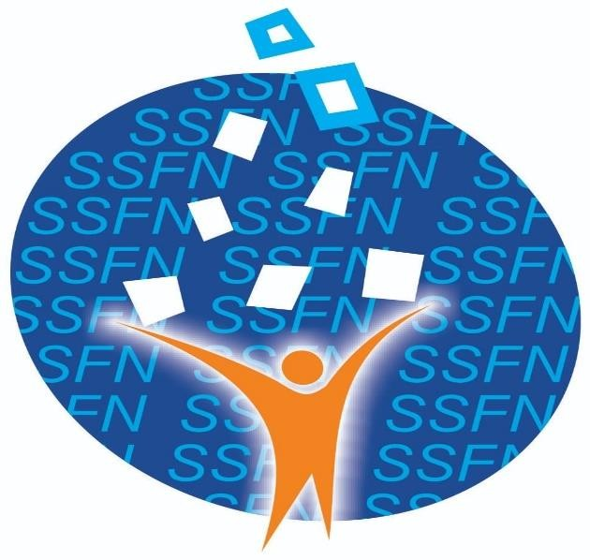

ANNUAL REPORT 2025 – 2026

** ADDRESS **
OFFICE NO. 1, 2& 3 GANGA NIWAS VIR SAVARKAR
NAGAR,
ASHOK NAGAR ROAD, SATPUR NASHIK -422012.
PHONE NO. 0253 – 2369999,
MOB. NO. 9011197777, 9011230555
Email: snehsadanfoundation@gmail.com

• INTRODUCTION :-
As a one of the part of organization to develop unorganized woman, youth and community children.
Snehsadan foundation, Nashik is a registered organization reg .no.MH/2817/2014/ Nashik .Trust Reg. No. F-15235 /Nashik .Date on 06 Sep 2014 .Working in Nashik District , Maharashtra .It was incepted in the year 2014 and since its inception the organization working with the people towards the economic , social ,environment ,Heath ,Social Awareness and education promotion of the woman and children .Over the last year Snehsadan Foundation ,Nashik worked to identify the need and meet the aspiration of the rural & urban poor and weaker section through participatory approaches .The organization conducted survey in slum area . The organization take decision Awareness raising ,Community healthcare, child labour, child begging, elimination and rehabilitation, environment protection, tuberculosis, Pulse polio, Immunization Swine Flu, HIV/AIDS awareness, income generation activities, like that training for woman and skill development activities, personality Development Activities in rural and slum people, mainly the organization concentrate Woman heath, Youth and Children Education Activities, natural resources management, poverty alleviation, small family concept, woman and children development activities are the major thirst areas of the organization activities. The organization take focus to quality education to rural and urban children, the organization conducted skill development activities to Children, youth and Woman .
The organization was also working with woman empowerment give vocational training and creates self-employment to woman during last year Snehsadan Foundation , Nashik has initiated a lot of activities on Child labour ,community child , collecting scrap child ,child Begging ,child Education issues .It has mobile public opinion against child labour .child begging ,child Education by organizing various workshop, parents meeting and signature champions at local level .

Vision :-
To create a quality of life.

Mission :-
The organization has to develop training institute for the poor and needy people, to provide skilled education for the
children, woman awareness for the Health and Education,
Cultural, Global warming. to evaluation for research, right shelter of orphan people to research water save To attempt poverty need, capacity building general equality, cumulate harmony, right to education .

Goal:-
“Quality of health and education society”

The following are objective considered by the Snehsadan Foundation, Nashik.

Objectives:-

- To provide for cultural education and implementation.
- To aware science, art crafts and implementation.
- To provide Vasti School, Shelter, Triber school, English Medium for rural children.
- To provide quality education and awareness to education.
- To arrange the workshop, seminars, training camp, discussions in rural area for youth & woman’s children.
- To provide various types of vocational training for children and woman.
- To create educational opportunities for children living in slums.
- To provide scholarship facility for educated children.
Create self-help Group and give Self-employment.
- To study for social changes and employment.
- To provide personality development programme of various resource person.
Taking cultural Activities for the woman and children.
- Arrange the Health camp.
- Helping regarding Gov. Scheme facilities.
- To provide health facilities about HIV Aids, Tuberculosis and major suffers.
- To provide dispensary, charity dispensary in rural and urban area.
- To provide computer education for rural and urban area.
- To awareness for the information technology.
- To provide Balwadi , Anganwadi ,Primary education in rural and urban area.
- To awareness for environment and protection for environment.
- To tree plantation and aware for global warming.
- To study and research of pollution.
- To provide facilities for woman shelter, senior citizen shelter, orphan shelter, in the rural and urban area.
- To provide centre for study circle and guideline.

ACTIVITIES
The activities are the conducted for the formal and non-formal education for the rural and urban children capacity build line of the slum dwellers with their active participation .All the Nashik City, Deola , Satana , Niphad , Kalwan ,Yeola ,Sinner ,Malegaon, Dindori, Manmad, Chandwad, Lasalgaon,Pimpalgaon Baswant, Igatpuri , Nashik District Area.

Self–help group-the organization is the promoting self-help group; make the available own resource to solve their own problem at their doorstep.

1. Back ground of the TI project
This core composite TI of Snehsadan Foundation, Nashik has registered MSM, TG, FSW in operational sites of the project under Snehsadan Foundation CC project intervention area in Nashik, Malegaon and Manmad of Nashik district. Snehsadan Foundation CC has finalized sites on the basis of the active MSM / TG/ FSW population available with CMIS.As per the current division of sites, following will be the status of this TI. Project would be working with, 150 TG, 1250 MSM, 600 FSW. Project will identify new privately operating sites where we propose to start an intervention in this year.
Snehsadan Foundation, Nashik through its work with MSM, TG, and FSW has established good rapport with this difficult-to-reach community. The NGO is therefore well-positioned to take this work forward with MSM, TG and FSW community. Under this proposed project, Snehsadan Foundation, Nashik will continue its work with as a core composite TI with an active population of 2000 MSM, TG, FSW population in Nashik , Malegaon and Manmad towns to achieve the targets as specified in the attached “Growth Indicator” table as per NACO guidelines and as required under the MSACS’ funding for the project.

Targeted Intervention Project for CC (MSM, TG & FSW) Nashik: (Supported by MSACS)

The Snehsadan Foundation has been implementing targeted intervention for HIV with CC
(MSM, TG & FSW) in Nashik district funded by Maharashtra State AIDS Control Society (NACO). The project is working with 2,000 (MSM, TG & FSW) from Nashik, Malegaon Manmad towns. Total (MSM, TG & FSW) registered since start of the project till March 26 was 2228. During April 2025 to March 2026, the project registered 674 (MSM, TG & FSW). Total clinic attendance for the said period of one year was 6885. Presumptive treatment was given to 100 (MSM, TG & FSW), 461 were detected with STI and were treated. 3553 (MSM, TG & FSW) were screened for HIV, which includes repeat testing, out of which was 12 HIV positive. As many as 276435 free Condoms were distributed, which show increased awareness among (MSM, TG & FSW) for condom usage. Many individual and group awareness sessions were conducted. Many events were conducted and celebration of various festivals like World Women’s Day, Ganapati, Navaratri was done.

• Stakeholders and activity plan to engage them in the project.
Advocacy and networking has been one of the focus areas in the TI implemented through the project. Building linkages with various stakeholders like the Police Department, brothels owners, RPs, banks ,media, women and child welfare department, Municipal corporation, collector office etc., has been an important advocacy activity of the project and project has been able to develop strong linkages with the above mentioned stake holders. 12 sensitization meetings were organized with the police, brothel owners and other stakeholders in Nashik district. The project will continue organizing need-based sensitization programs and meetings with the police and other stakeholders. Snehsadan Foundation will focus mainly on those police stations where incidences of KP harassment are higher and will hold at least one meeting per month with the police.
Project is closely working with collector office and women and child welfare department for social entitlements of the community. Secondary stakeholders will be the partners in the project who will help plan community mobilization activities, conduct events, etc. Police, local leaders and other stakeholders will be included in these meetings.

Community - based Activities
- Above objective will be achieved through the strategy of Behaviour Change Communication (BCC). BCC is a multi-level tool to promote and sustain risk reducing behaviour change in individuals and communities by distributing tailored health messages through a variety of communication channels. Following are the various activities that will be carried out to achieve above-mentioned objective with the MSM, TG and FSW population in the project area.
- One-to-one sessions will cover STI/HIV/AIDS, prevention of HIV/AIDS (through ABCD methods) and treatment. Tools that will be used to conduct one-to-one session are personal interactions, flip charts, games and condom demonstrations (demos) and redemonstrations (re-demos). Individuals with STIs, sexual health problems, risk behaviour and HIV will be identified from these sessions and referred to counselors for further, intensive follow-up. BCC materials will be distributed during these sessions. In addition, condom demonstrations will be undertaken to increase awareness of correct and consistent use of condom. Community members will be requested to perform redemos to ensure that the correct message has been delivered.
- Group Sessions
- Group sessions will be conducted by PEs supported by FO/ORWs which will cover the topics of STI/HIV/AIDS prevention of HIV/AIDS (through ABCD methods) and treatment. Other sexual health problems, myths and misconceptions faced by the group will be addressed. BCC materials will be distributed during the sessions. In addition, condom demonstrations will be undertaken to increase awareness on correct and consistent use of condoms. Community members will be requested to perform redemos to ensure that the correct message is delivered.
- Tools that will be used to conduct one to group sessions are personal interactions, flip charts, games, role play, etc. Individuals with STIs, sexual health problems, risk behaviour and HIV will be identified from these sessions and referred to counsellors for further, intensive follow-up. Potential PEs will be identified through these sessions.This would be achieved by DIC level meetings.
The project has mobilized MSM and TG community in Malegaon and Manmad through formation of groups and conducting various events at town level and district level. More emphasis will be given to the effective tracking of population , prepare microplan to increase its coverage, strengthen community committees so that they are able to plan, mobilize more number of KPs and their active participation in the project activities is ensured. The project will motivate and support PLHIV community members to be part of and be active member of support groups.

Current Working

- To start HIV/AIDS awareness.
- To start provide PLHIV patient services.
- Arrange General Health Camp
- Hepatitis B & C Camp

Future plan:-

- To start multibody check-up camp.
- To start street play about Health and Education.
- To start Woman empowerment program.

“World AIDS Day Rally”
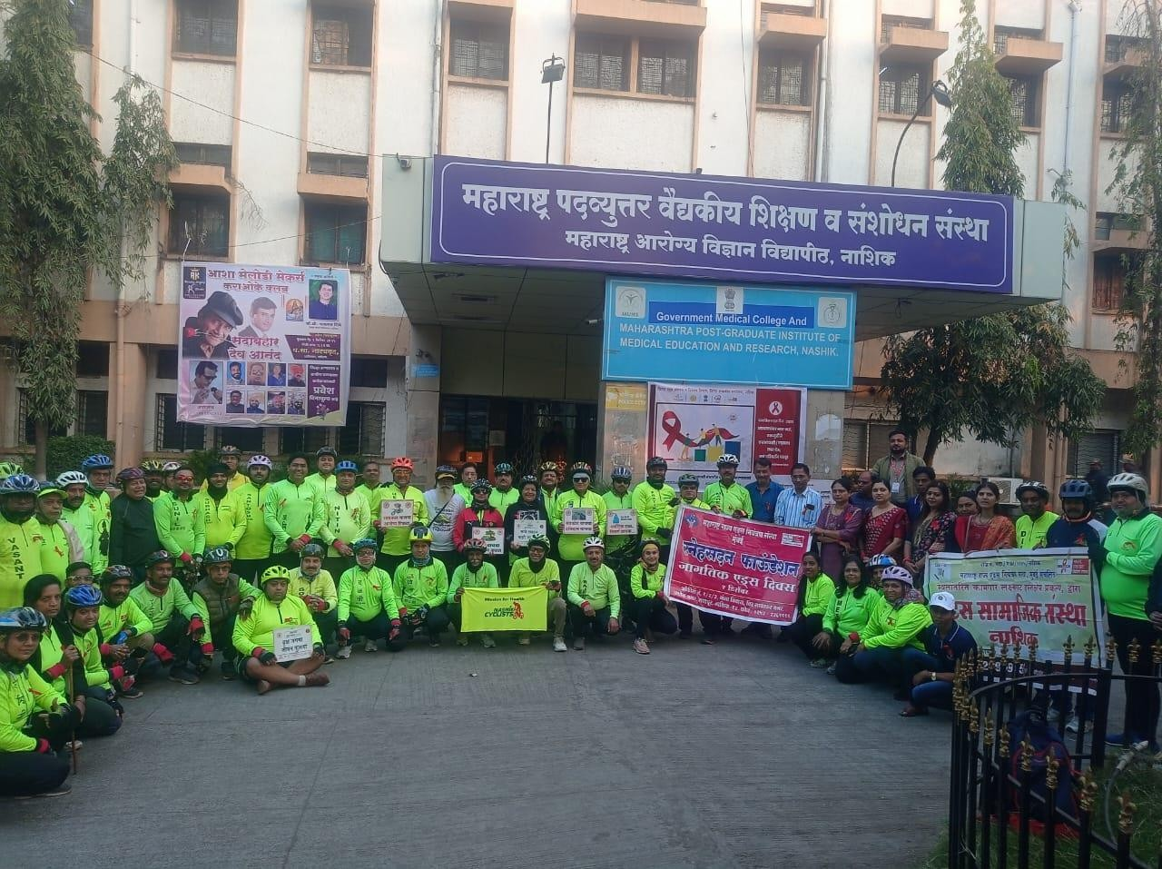

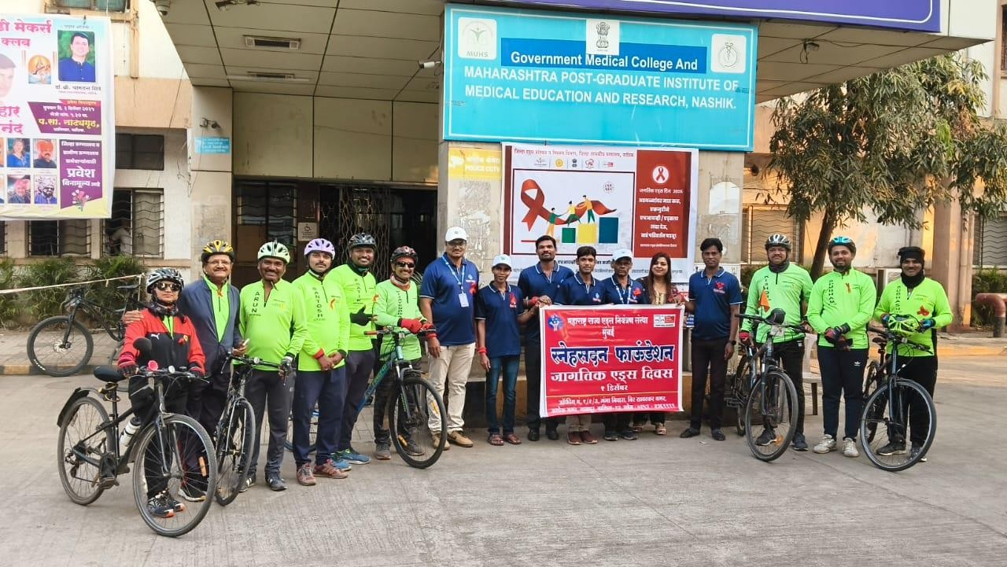

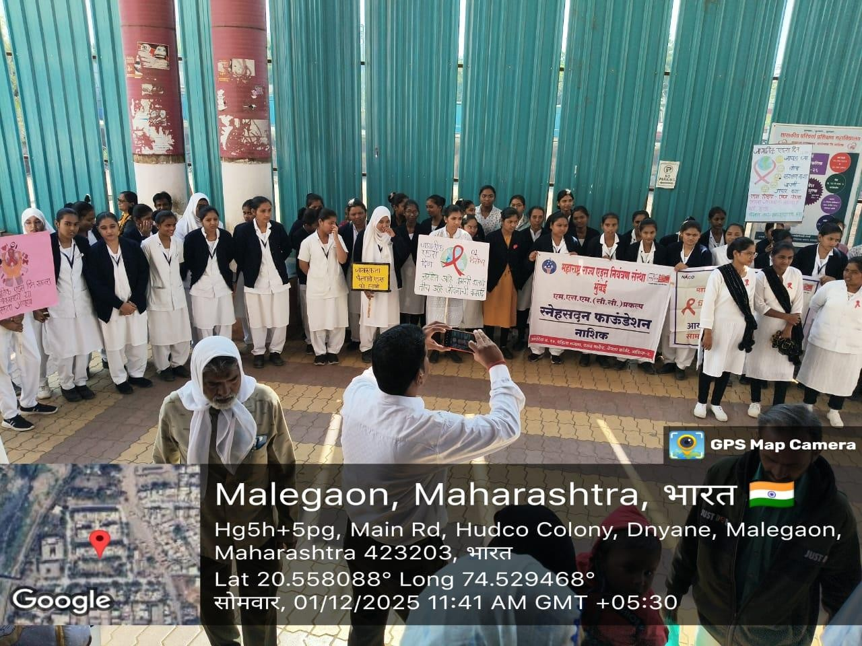

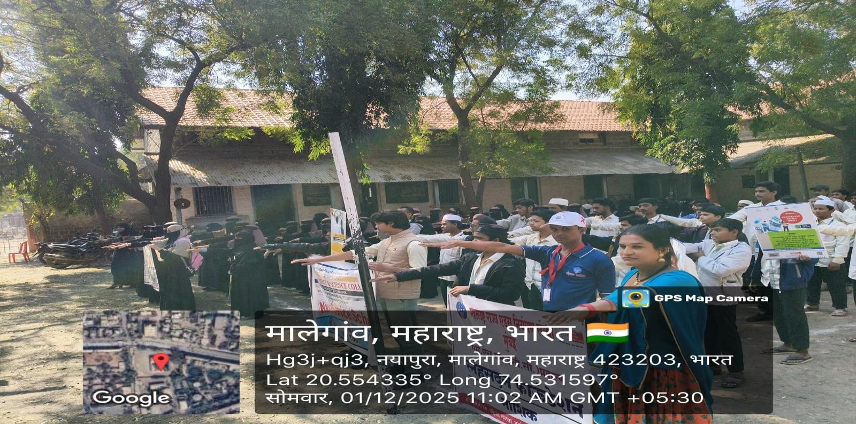

“Community Event & TG Card Distribution Malegaon”
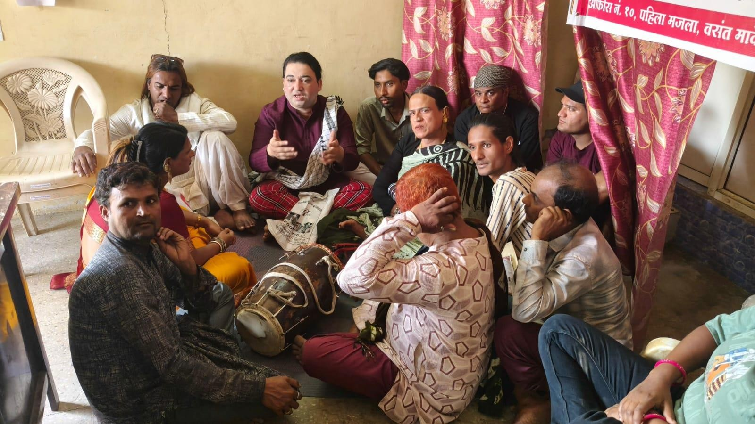

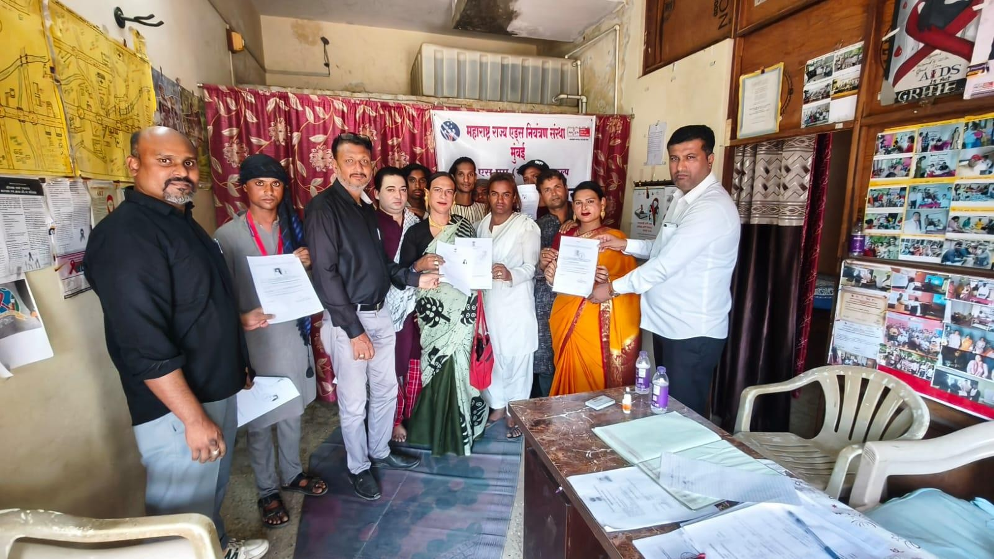

“Health Camp”
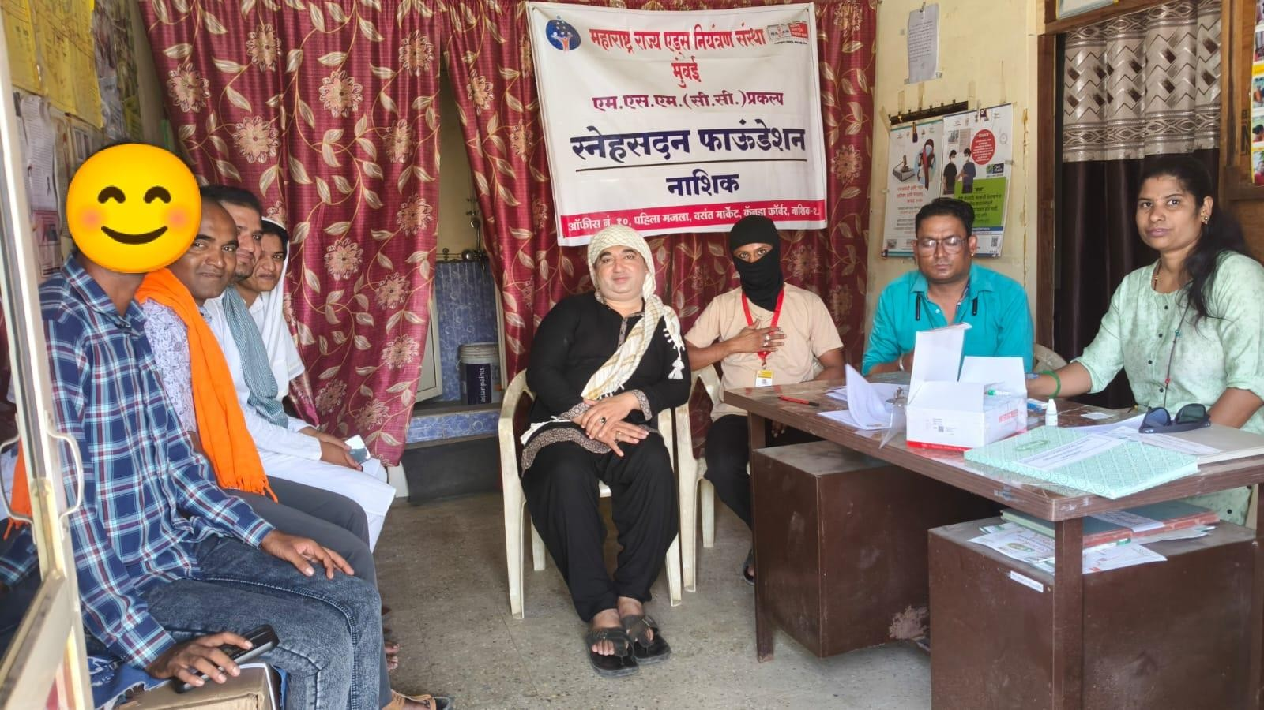

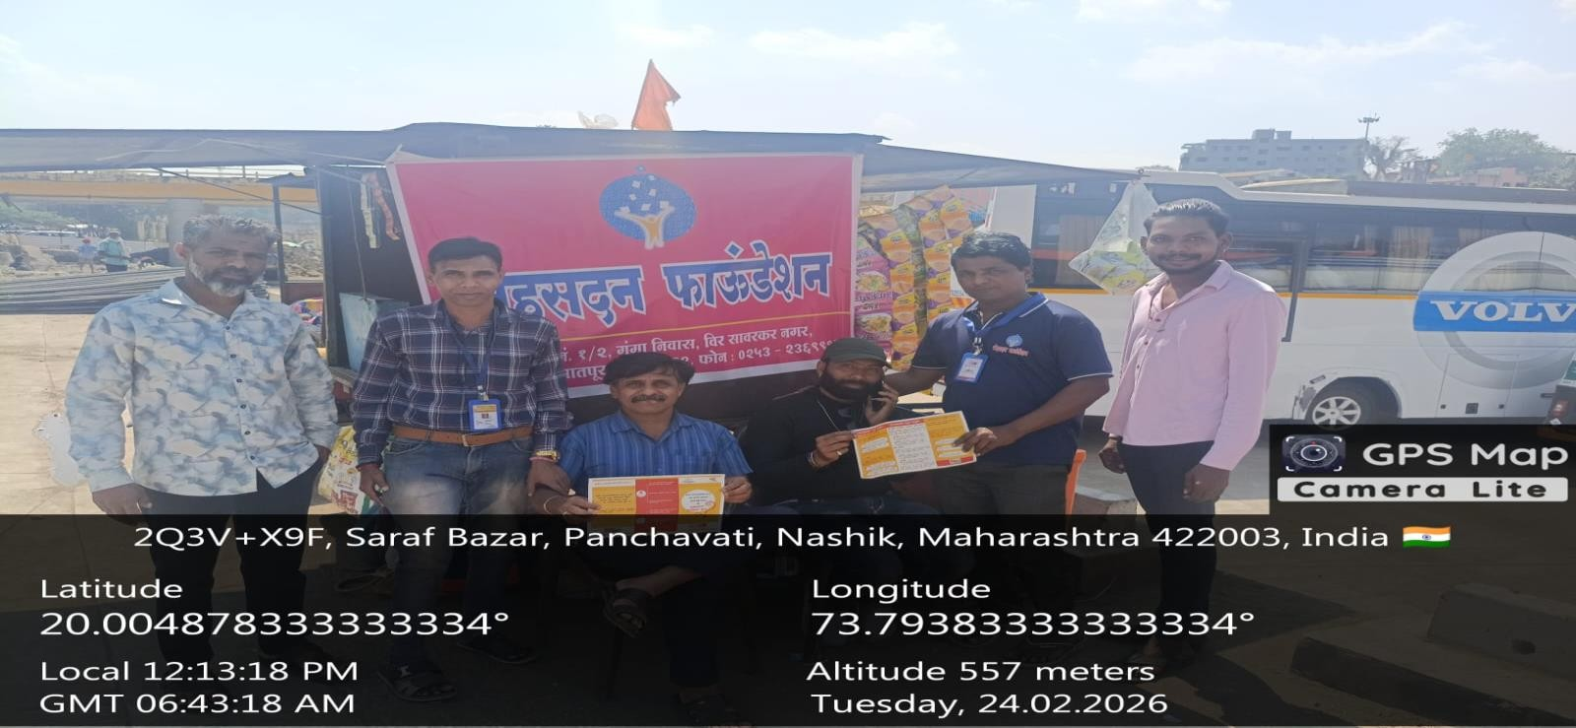

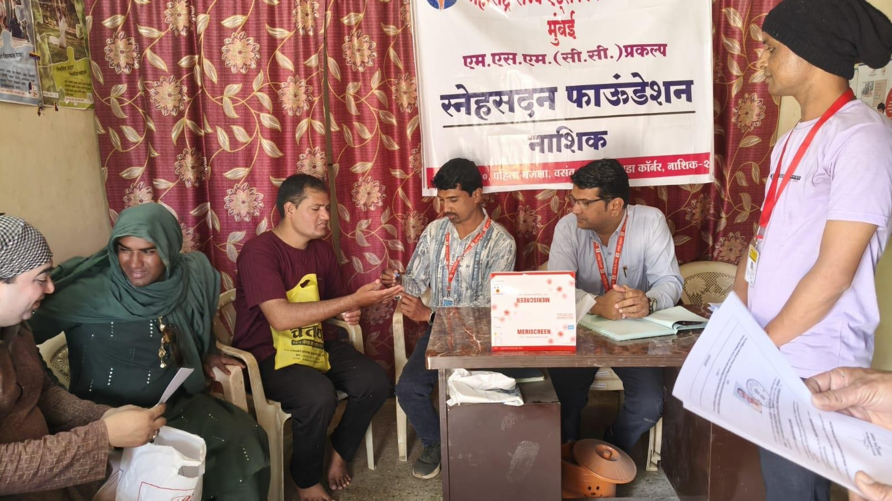

“Site Visit”
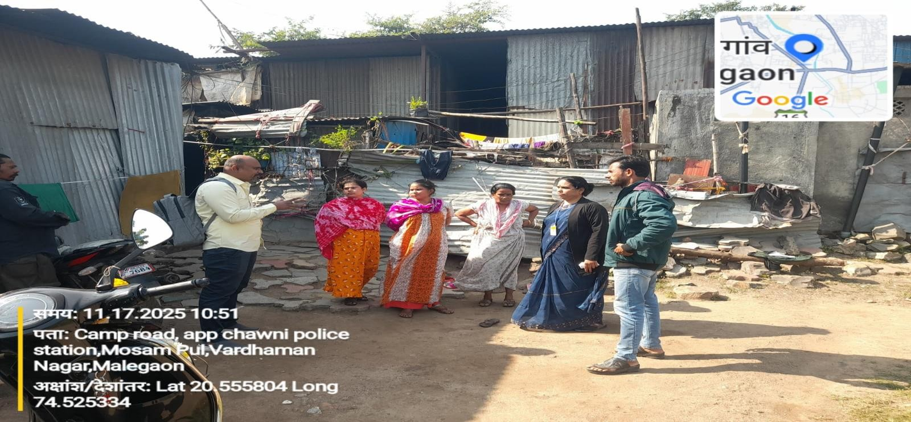

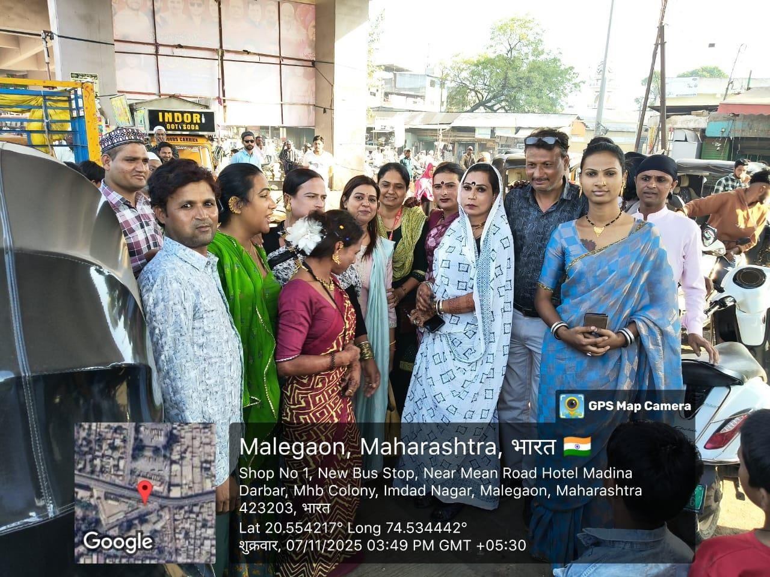

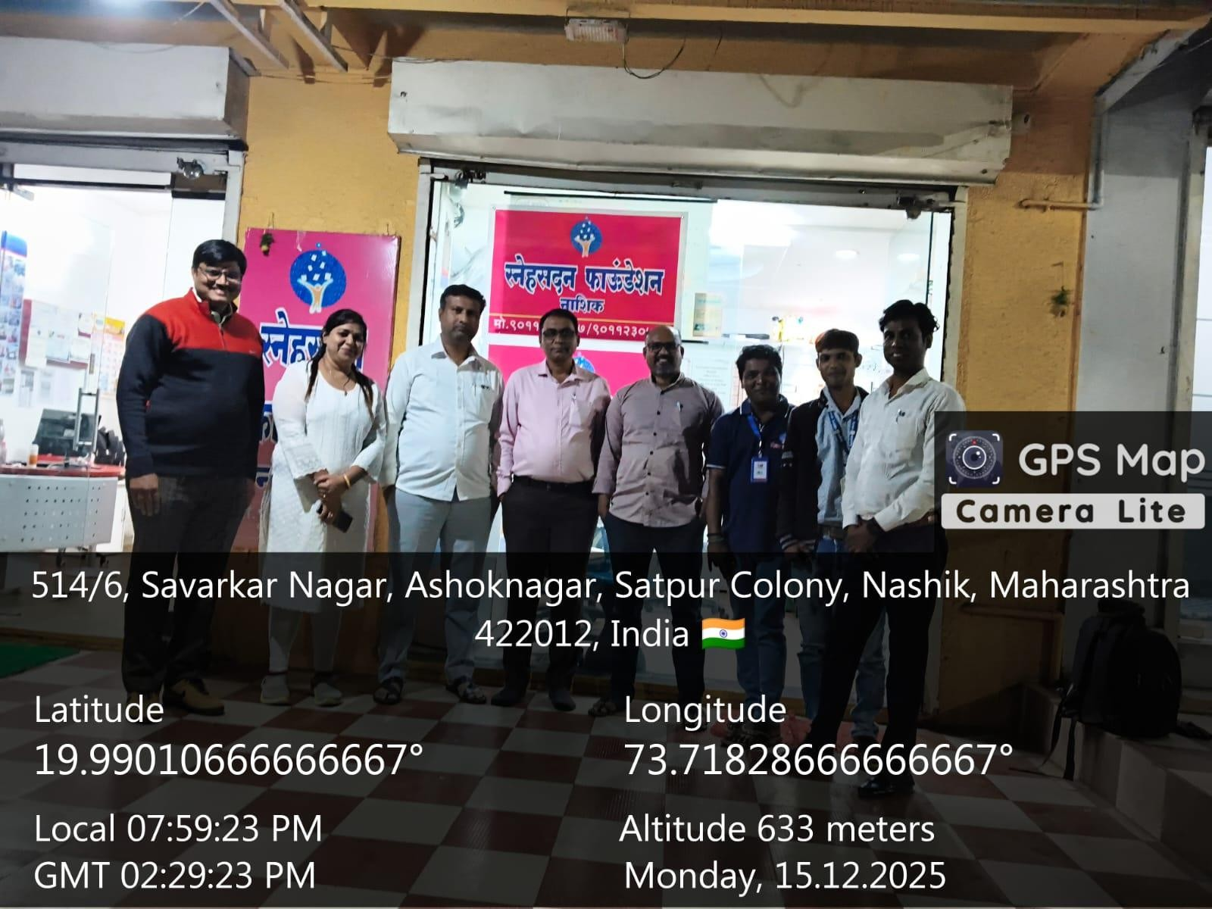
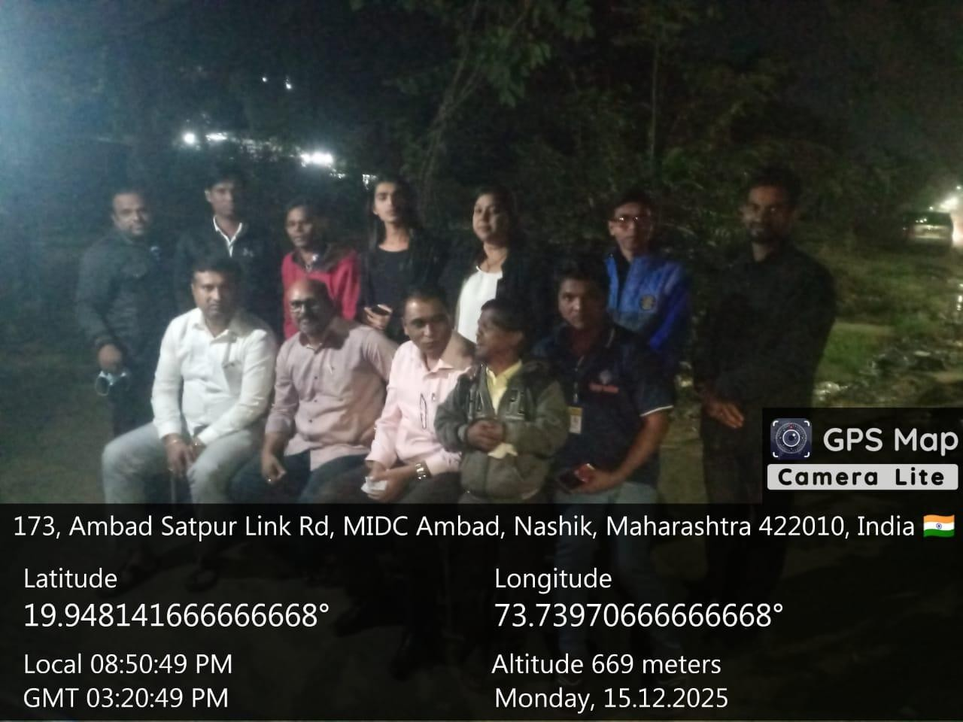

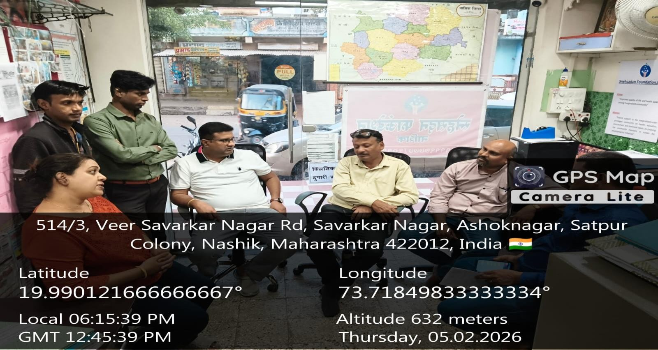
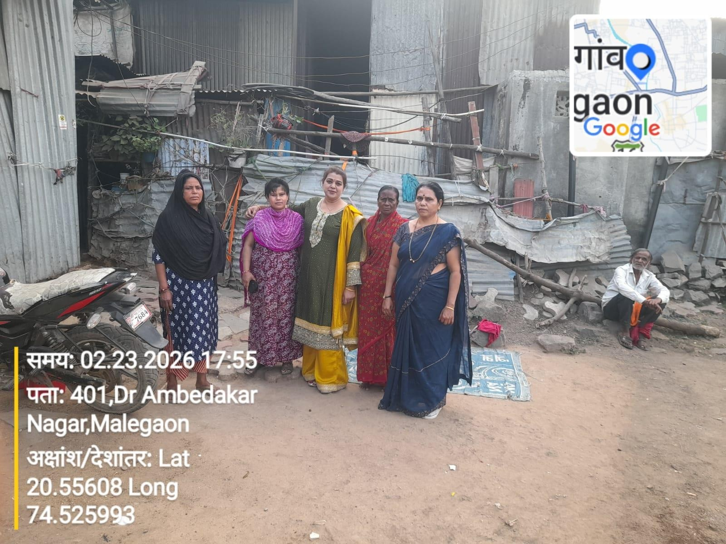

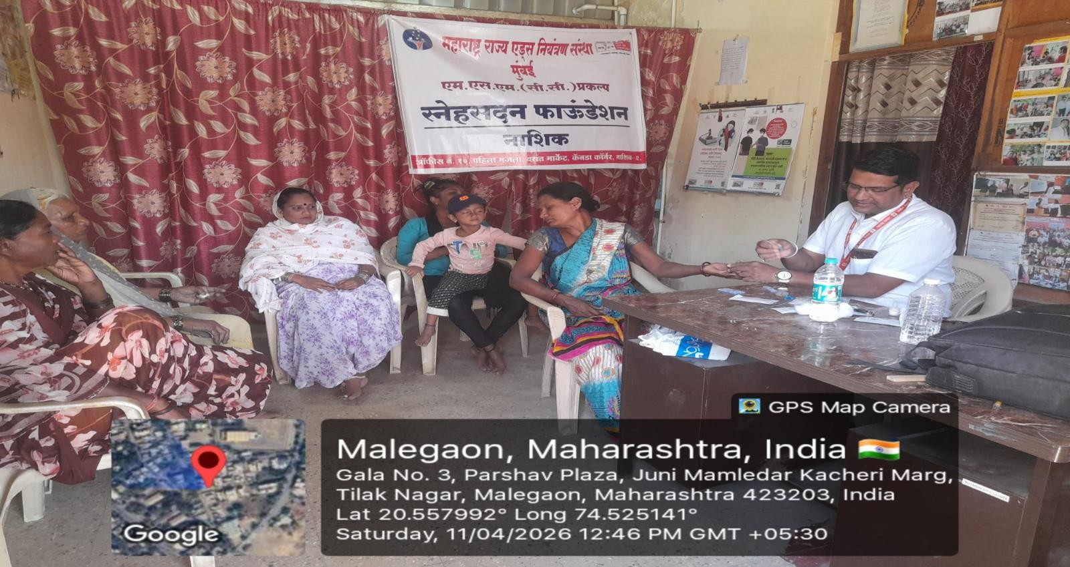

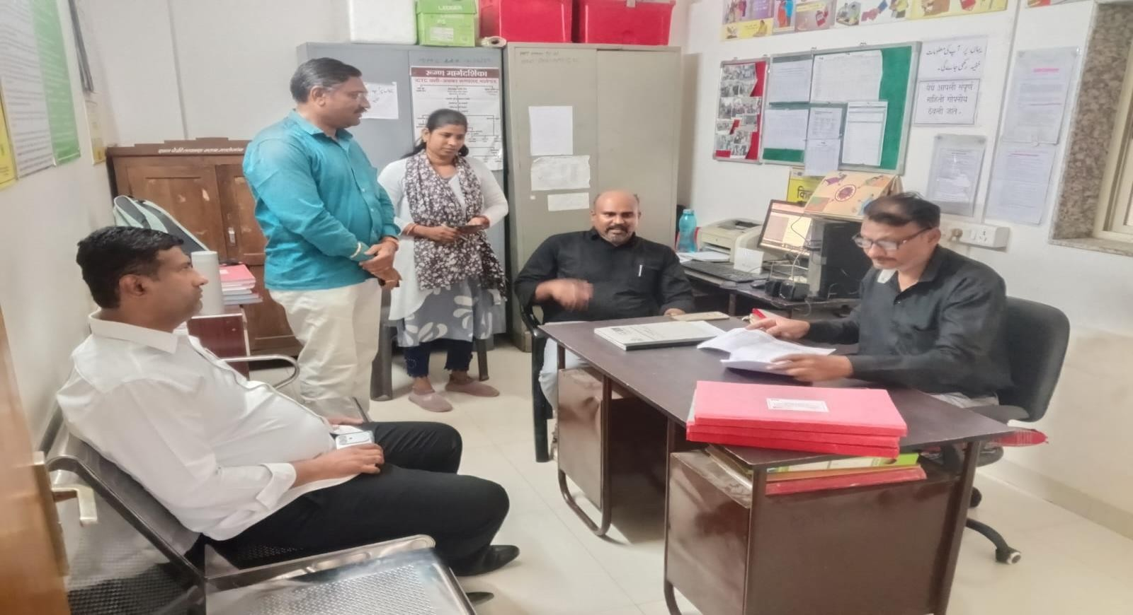

Thanks:-
Many prominent Visitor & guest visited NGO in reporting year. They guided us. I am thankful to them.
I am thankful to all trustee member well-wishes of organization. Expecting all co-operation in coming year.

*****Thank You*****
SNEHSADAN FOUNDATION

